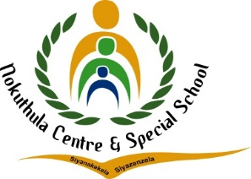


TEL: (010) 023 0609
E-MAIL: nokuthulasmh@mweb.co.za
NPO No: 001041
________________________________________________________
LESSON PLAN

Subject: Life Skills | Grade: 3 year 2 |  |  | Term: 1 |  |  | Week: 4-5
Topic: Keeping my body safe (Rights and responsibilities) |  | Content: Personal wellbeing | Time allocation: 1 week |  |  | Date Started: 5 febreuary 2024 |  | Date Completed:
Prior content knowledge:  Content knowledge from life skills grade 3 year 1 (about me) | Lesson objectives: for learners to be aware of their rights and responsibilities.  Knowing how to say NO! to any form of Abuse.  Knowing how to report Abuse. |  |  |  | Vocabulary /Important word: DBE Books pages 26-27. 1 alternative activity in the exercise book. |  |  |  | Teaching Strategies:  Demonstrate  Observation  Questions and Answers
Resources: DBE workbooks, exercise book and vocabulary words, Pictures and Posters. | Teacher Activities: Teaching learners about their rights and responsibilities.  Teaching learners to be aware of different abuse and how to say NO! to it. |  |  |  | Learner Activities: They must learn about their rights and responsibilities they must write sentences on yes and No feelings.  They must differentiate between rights and responsibilities. |  |  |  | Assessment Goal:  Assessment Strategy  Informal  Formal  Assessment tool: Rubric

Differentiation (Enrichment opportunities/addressing barriers) | Practical task
- Group 1: Learning how to say NO to different abuses  - Group 2: Write sentences on YES and NO feeling.  - Group3: Knowing how to differentiate between rights and responsibilities. | Locomotor, wheelbarrow and panting.
Teacher Reflection: | Name of Teacher: Tlotlang Tsiu
HOD Input: | Name of HOD: Steven

